MPG Analysis

Cliff Lau

## Executive Summary

For this analysis, we investigated the impact of Mile Per Gallon (MPG) from automatic and manual transmission. Based on our analysis, we found no evidence to support using either automatic or manual transmission will lead to a different MPG.

## Analysis

We will be using the mtcars dataset from R as well as package ggplot2 and dplyr for our analysis.

library(ggplot2)  
library(dplyr)  
  
data(mtcars)

For the mtcars dataset, we're mostly interested in the mpg and am variables. But we should also consider someother confounding variables that might affect the mpg and mask the true effect of auto vs manual.

First, we'll rename the am column and change it to factor.

mtcars <-   
 tbl_df(mtcars) %>%  
 mutate(am = as.factor(ifelse(am == 0, "automatic", "manual")),  
 cyl = as.factor(cyl))

Next, we performanced some summary analysis on the dataset:

glimpse(mtcars)

## Observations: 32  
## Variables:  
## $ mpg (dbl) 21.0, 21.0, 22.8, 21.4, 18.7, 18.1, 14.3, 24.4, 22.8, 19....  
## $ cyl (fctr) 6, 6, 4, 6, 8, 6, 8, 4, 4, 6, 6, 8, 8, 8, 8, 8, 8, 4, 4,...  
## $ disp (dbl) 160.0, 160.0, 108.0, 258.0, 360.0, 225.0, 360.0, 146.7, 1...  
## $ hp (dbl) 110, 110, 93, 110, 175, 105, 245, 62, 95, 123, 123, 180, ...  
## $ drat (dbl) 3.90, 3.90, 3.85, 3.08, 3.15, 2.76, 3.21, 3.69, 3.92, 3.9...  
## $ wt (dbl) 2.620, 2.875, 2.320, 3.215, 3.440, 3.460, 3.570, 3.190, 3...  
## $ qsec (dbl) 16.46, 17.02, 18.61, 19.44, 17.02, 20.22, 15.84, 20.00, 2...  
## $ vs (dbl) 0, 0, 1, 1, 0, 1, 0, 1, 1, 1, 1, 0, 0, 0, 0, 0, 0, 1, 1, ...  
## $ am (fctr) manual, manual, manual, automatic, automatic, automatic,...  
## $ gear (dbl) 4, 4, 4, 3, 3, 3, 3, 4, 4, 4, 4, 3, 3, 3, 3, 3, 3, 4, 4, ...  
## $ carb (dbl) 4, 4, 1, 1, 2, 1, 4, 2, 2, 4, 4, 3, 3, 3, 4, 4, 4, 1, 2, ...

summary(mtcars)

## mpg cyl disp hp drat   
## Min. :10.40 4:11 Min. : 71.1 Min. : 52.0 Min. :2.760   
## 1st Qu.:15.43 6: 7 1st Qu.:120.8 1st Qu.: 96.5 1st Qu.:3.080   
## Median :19.20 8:14 Median :196.3 Median :123.0 Median :3.695   
## Mean :20.09 Mean :230.7 Mean :146.7 Mean :3.597   
## 3rd Qu.:22.80 3rd Qu.:326.0 3rd Qu.:180.0 3rd Qu.:3.920   
## Max. :33.90 Max. :472.0 Max. :335.0 Max. :4.930   
## wt qsec vs am   
## Min. :1.513 Min. :14.50 Min. :0.0000 automatic:19   
## 1st Qu.:2.581 1st Qu.:16.89 1st Qu.:0.0000 manual :13   
## Median :3.325 Median :17.71 Median :0.0000   
## Mean :3.217 Mean :17.85 Mean :0.4375   
## 3rd Qu.:3.610 3rd Qu.:18.90 3rd Qu.:1.0000   
## Max. :5.424 Max. :22.90 Max. :1.0000   
## gear carb   
## Min. :3.000 Min. :1.000   
## 1st Qu.:3.000 1st Qu.:2.000   
## Median :4.000 Median :2.000   
## Mean :3.688 Mean :2.812   
## 3rd Qu.:4.000 3rd Qu.:4.000   
## Max. :5.000 Max. :8.000

As well as some exploratory graphs:

ggplot(mtcars, aes(am, mpg, cyl)) +   
 geom_boxplot() +  
 facet_grid(.~cyl) +  
 ggtitle("MPG for Auto vs Manual by Number of Cylinders")

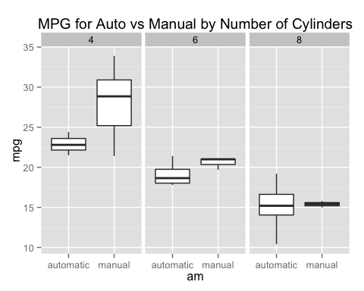

ggplot(mtcars, aes(wt, mpg, am))+   
 geom_line() +  
 geom_smooth(method = "lm") +  
 facet_grid( .~am) +  
 ggtitle("MPG based on Transmission Type")

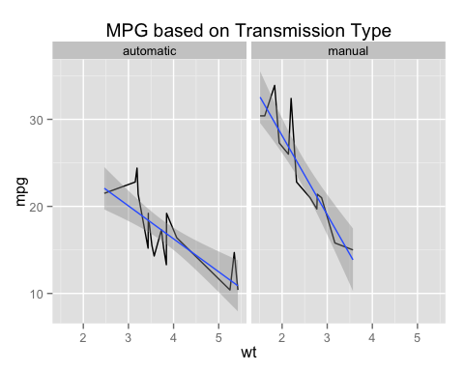

Based on the plots above, we might suspect that there is no difference in auto and manual transmission. To confirm, we'll fit a linear model with the 3 predictors: am, cyl, and wt:

fit2 <- lm(mpg ~ am + cyl + wt, data = mtcars)  
summary(fit2)

##   
## Call:  
## lm(formula = mpg ~ am + cyl + wt, data = mtcars)  
##   
## Residuals:  
## Min 1Q Median 3Q Max   
## -4.4898 -1.3116 -0.5039 1.4162 5.7758   
##   
## Coefficients:  
## Estimate Std. Error t value Pr(>|t|)   
## (Intercept) 33.7536 2.8135 11.997 2.5e-12 ***  
## ammanual 0.1501 1.3002 0.115 0.90895   
## cyl6 -4.2573 1.4112 -3.017 0.00551 **   
## cyl8 -6.0791 1.6837 -3.611 0.00123 **   
## wt -3.1496 0.9080 -3.469 0.00177 **   
## ---  
## Signif. codes: 0 '***' 0.001 '**' 0.01 '*' 0.05 '.' 0.1 ' ' 1  
##   
## Residual standard error: 2.603 on 27 degrees of freedom  
## Multiple R-squared: 0.8375, Adjusted R-squared: 0.8134   
## F-statistic: 34.79 on 4 and 27 DF, p-value: 2.73e-10

Based on the summary statistics above, we can see that the am predictor is not significant based on the p-value. Therefore, we can conclude that automatic vs manual makes no difference in terms of MPG.